A Recipe For:

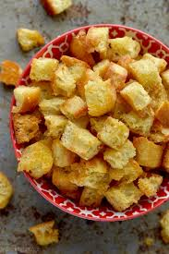 

# 

# Croutons

**From the Kitchen of:** Mom

**Servings:** 6 servings

**Prep Time:** 5 minutes **Bake Time:** 10 min **Bake Temp:** 325

**Ingredients:**

* 3 heaping cups cut or torn bread, stale or fresh
* 2 Tbsp olive oil
* 1/8 to ¼ tsp salt
* Optional extras: ground black pepper, garlic powder, Italian seasoning blends

**Instructions:**

1. Cut, tear bread into bite-sized chunks. You can leave the crust on or tear it off, your preference.
2. Add the bread to a large saute pan or cast iron skillet and drizzle with oil. Toss until most of the bread is coated in oil. Sprinkle with salt and any extra spices you’d like.
3. Cook over medium/high heat, jostling the croutons occasionally to evenly cook. They are done when most sides are golden brown and crispy, about 5 to 10 minutes. Allow to cool briefly before serving.
4. Store in the fridge in an airtight container with a paper towel. You can store for 5 to 7 days (may be thrown back in the pan right before eating to become crispy again)